Task - 21

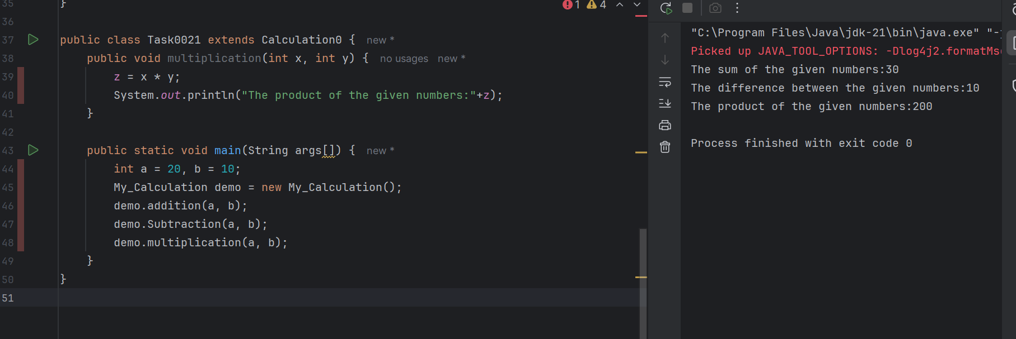

Task -22

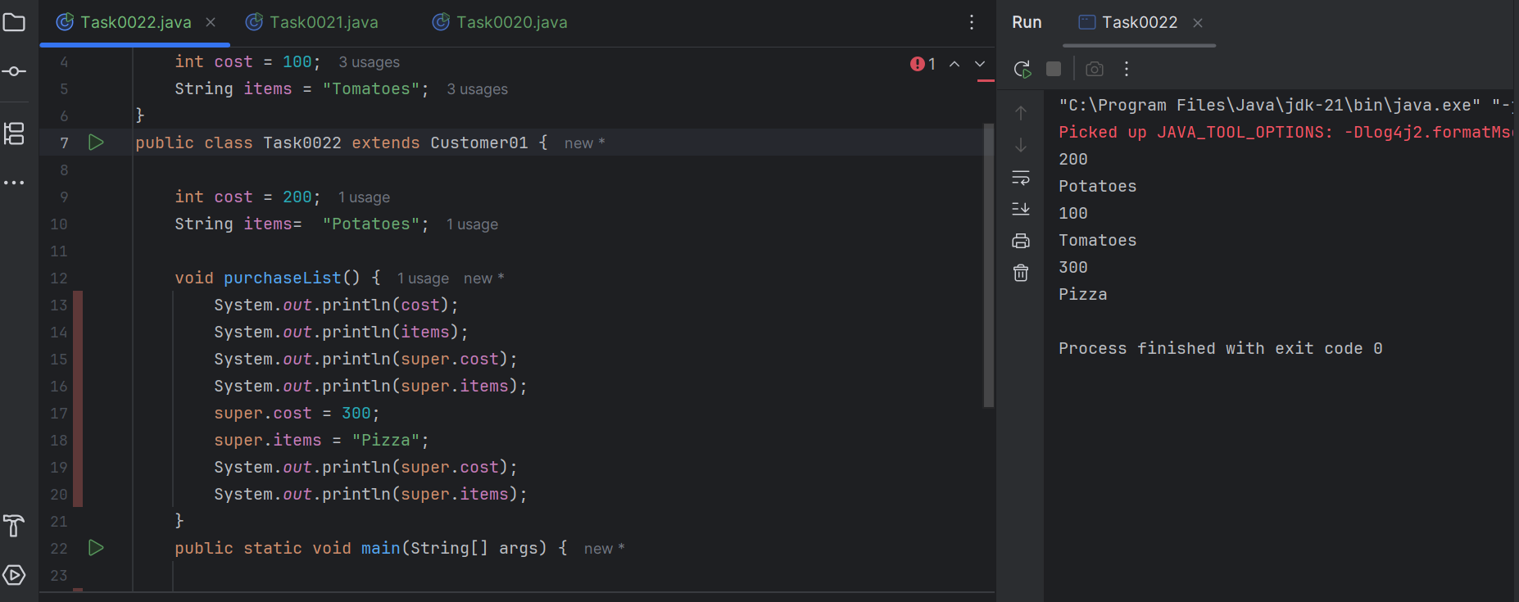

Task -23

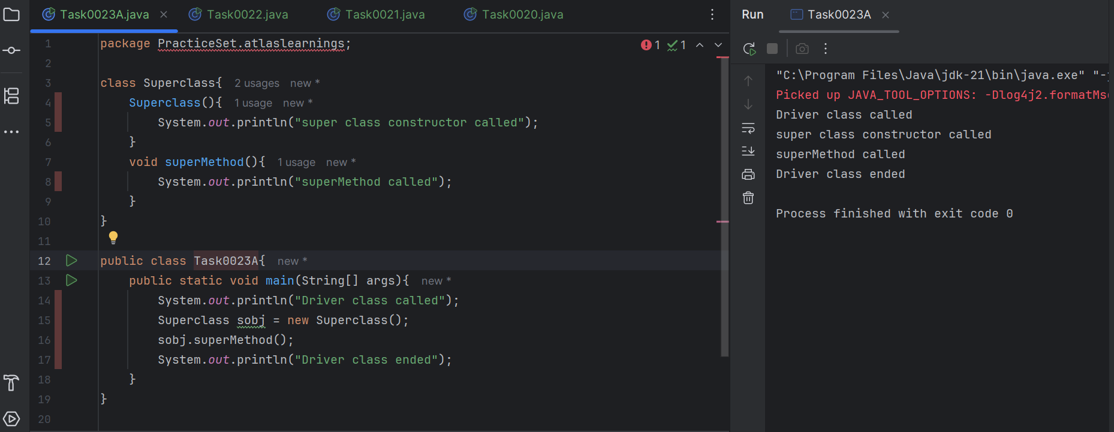

Task - 24:

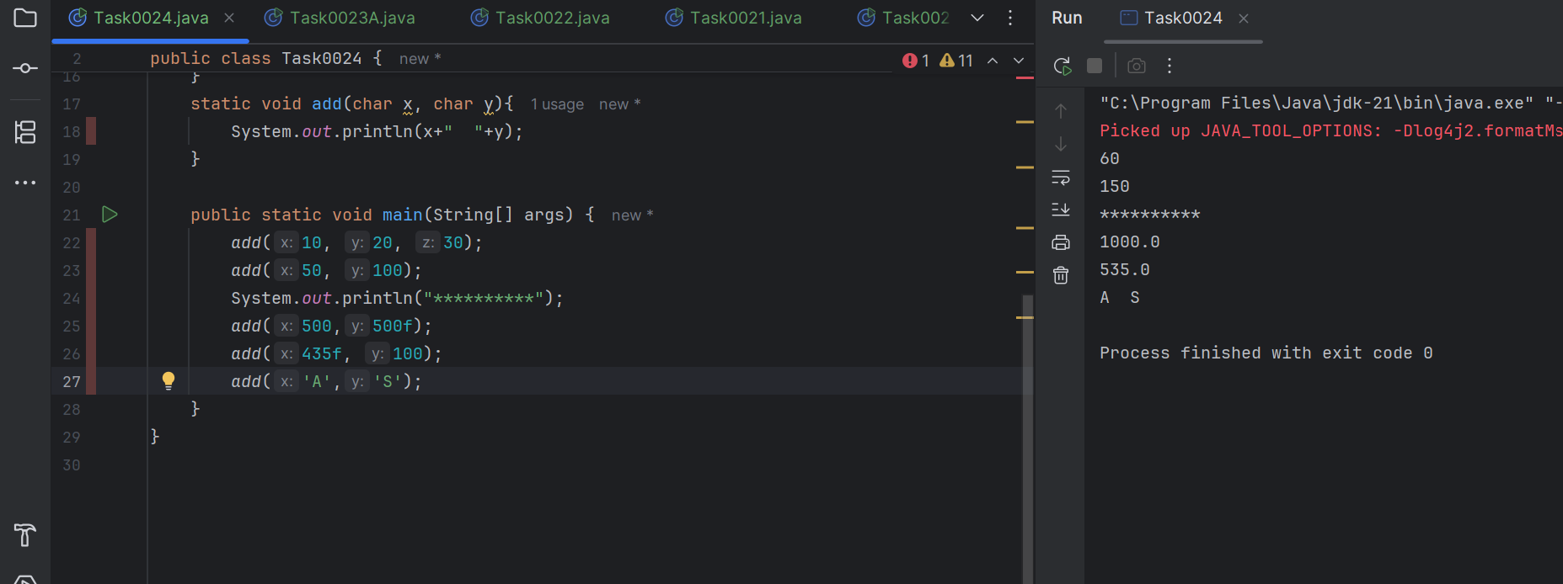

Task - 25:

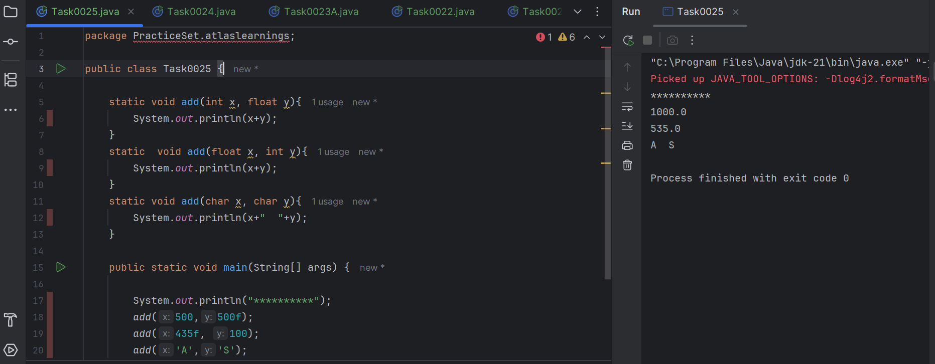

Task - 26:

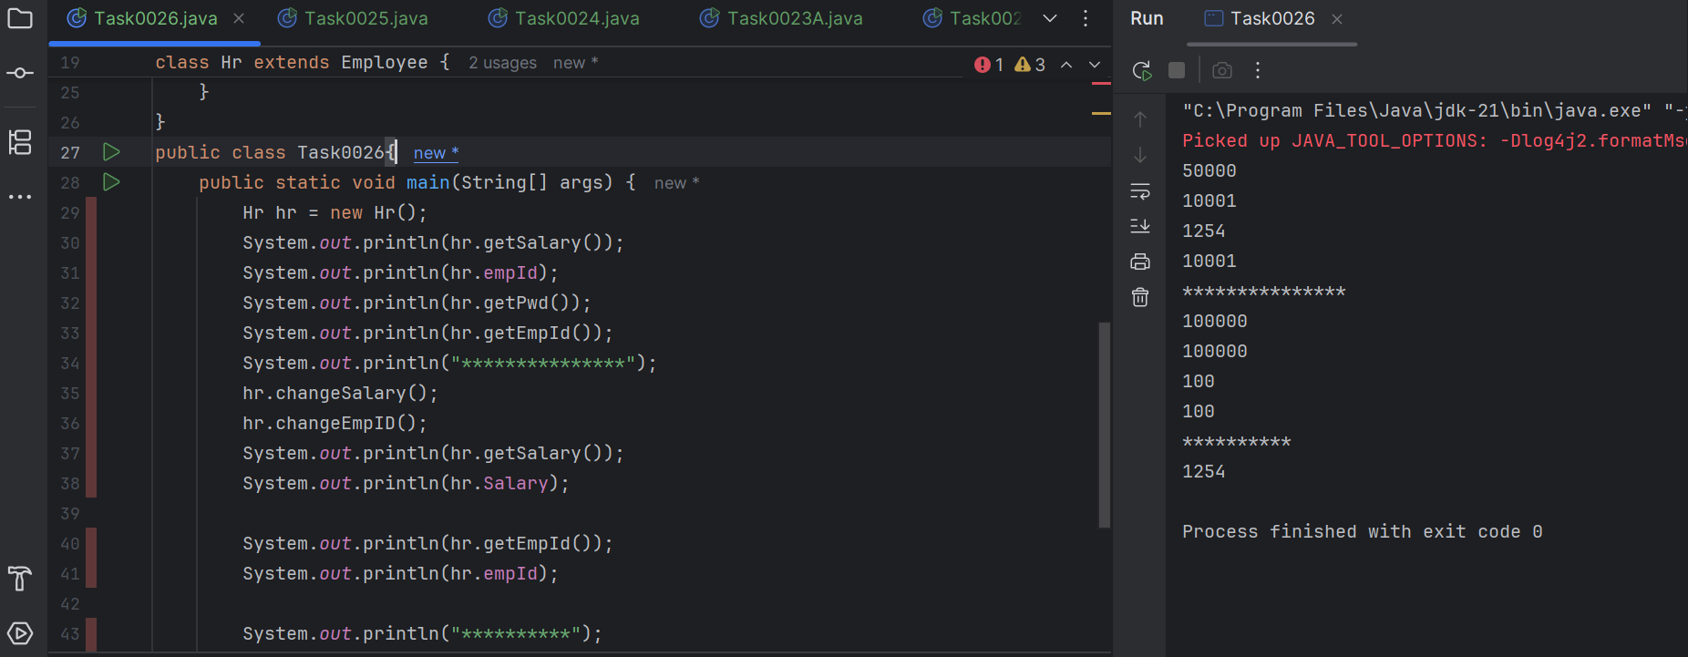

Task - 27:

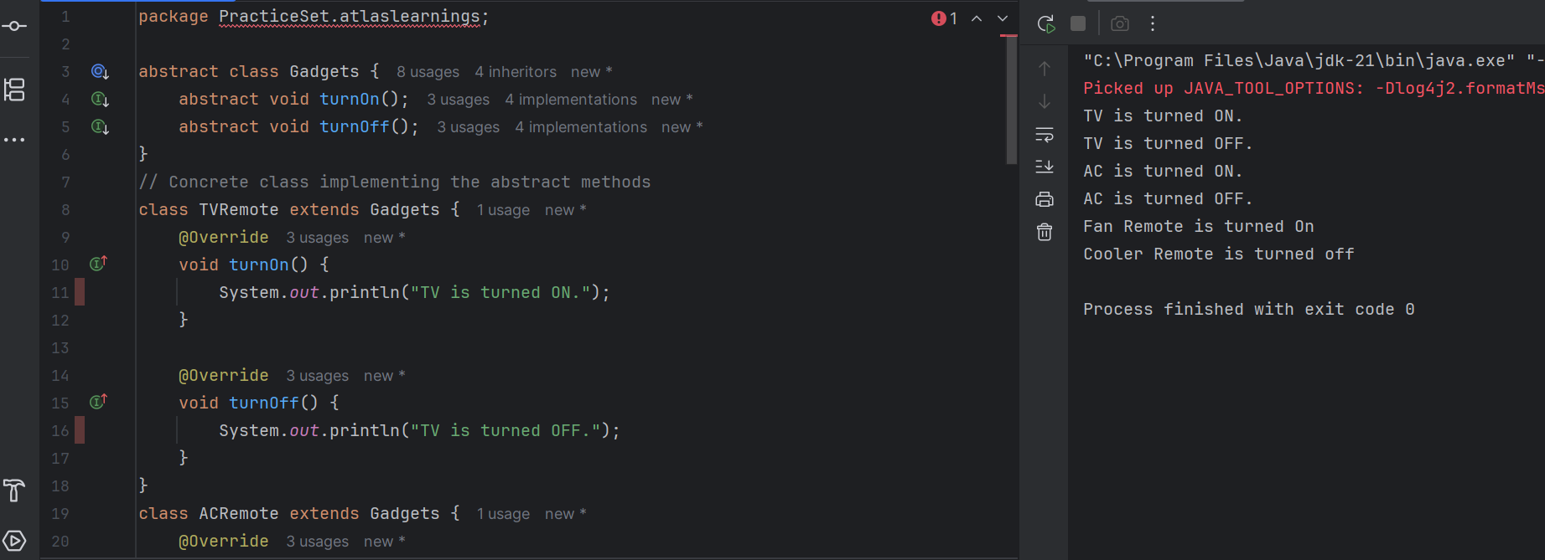

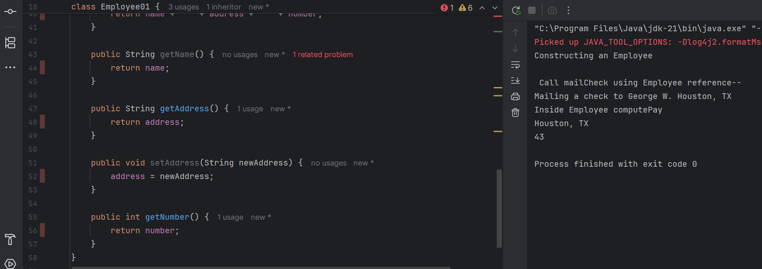

Task - 28:

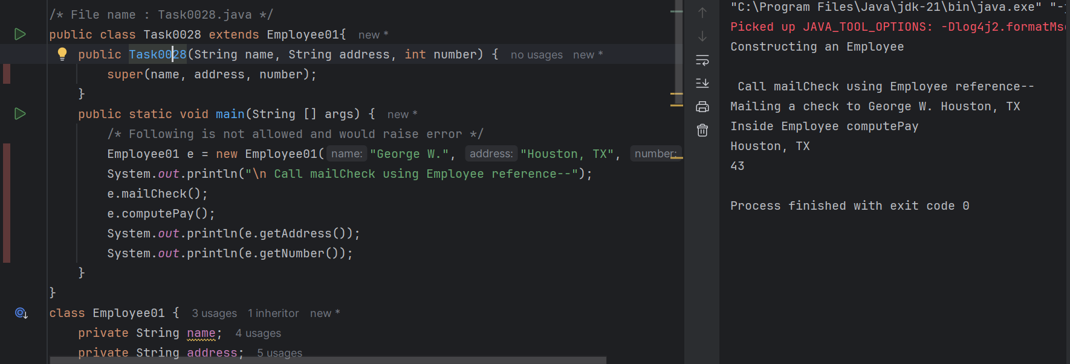

Task - 29:



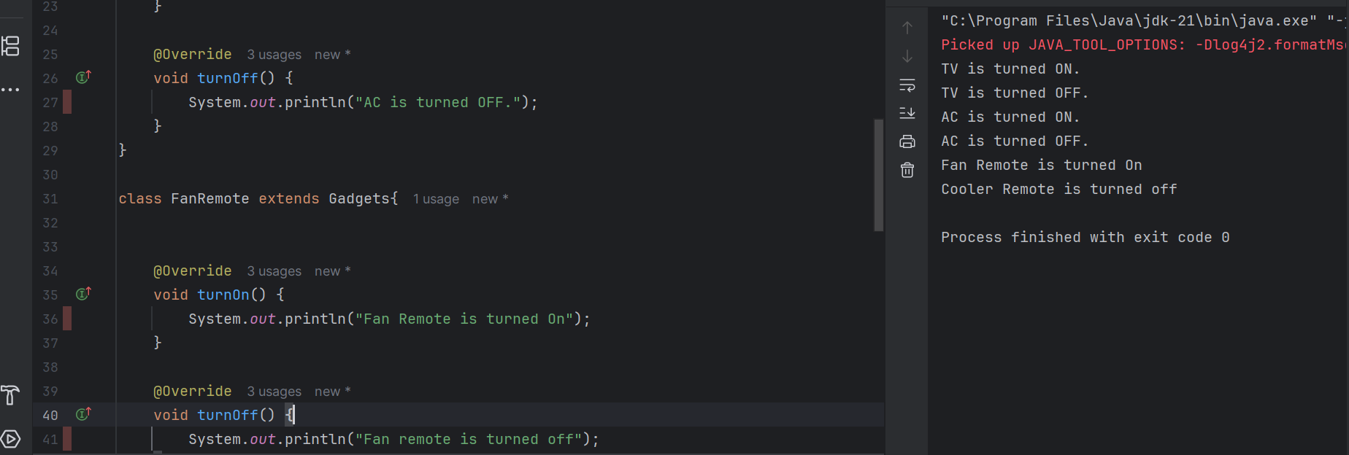

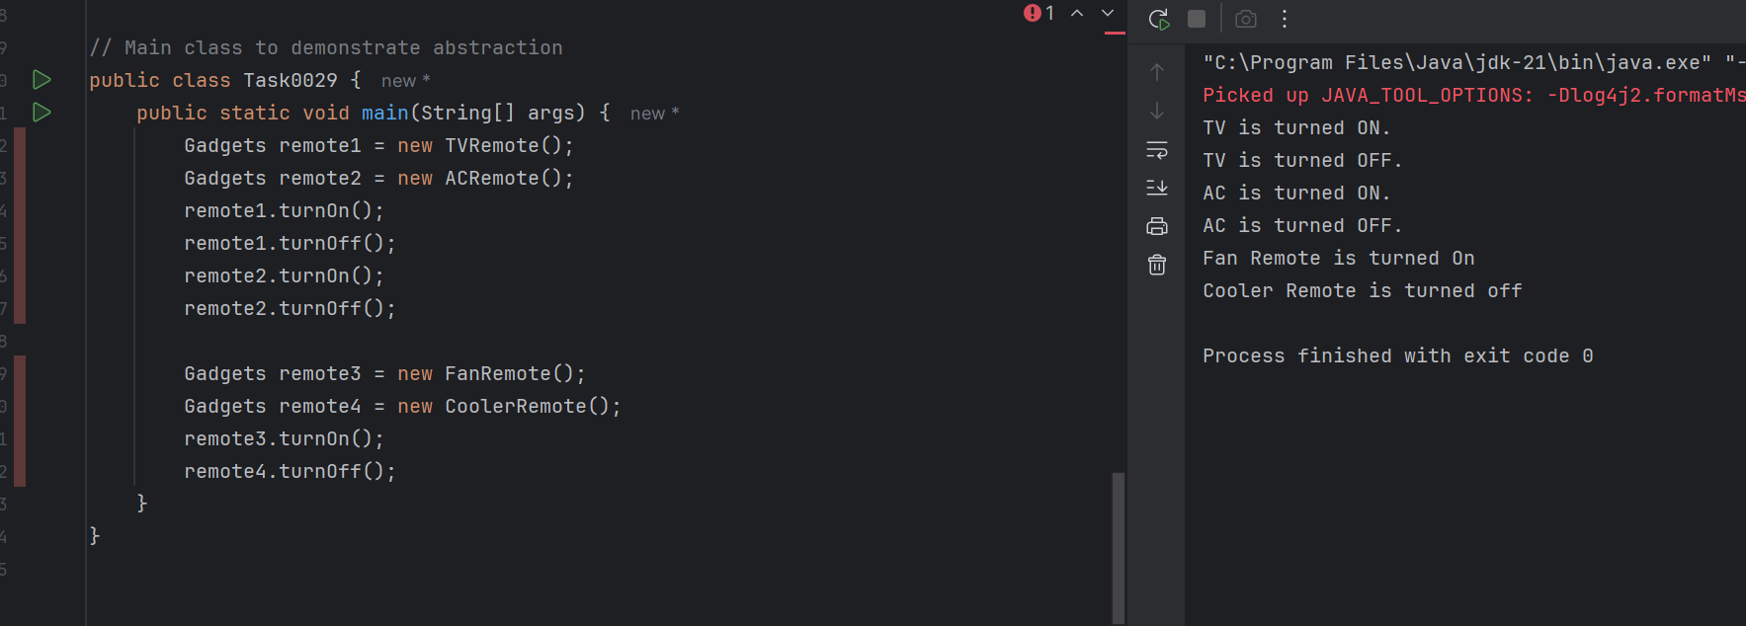

Task - 30:

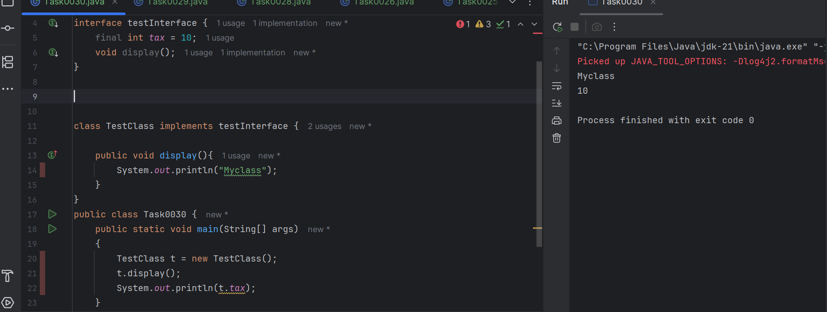

Task - 31:

Difference between constant and final

In Java, final is a keyword used to make a variable unchangeable after it is assigned. It can be used with variables, methods, and classes. A constant, on the other hand, is a special type of final variable that is also static and usually public, so it can be accessed globally. Constants are used to define fixed values like PI or MAX_VALUE, and are written in uppercase. So, all constants are final, but not all final variables are constants.